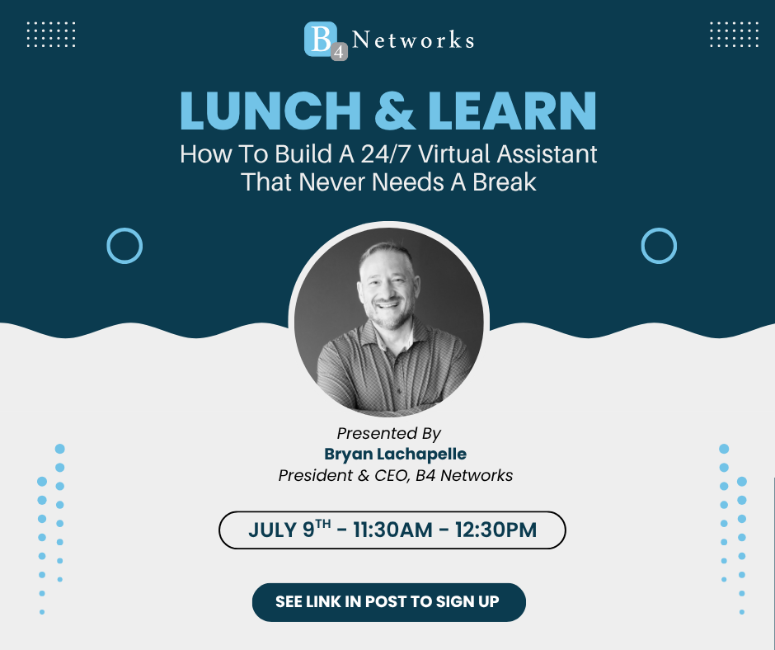

Step #1- Create your target market’s Business Profile
- Open ChatGPT to the default chat:
- Prompt #1: Please create for me a detailed business profile on the XYZ Market in the context of what they want or need to work with Your Industry.
- Save output as a document named “Business-Profile” using Word, or your preferred text editor.

An example for one of the industries we serve:
Example prompt: Please create for me a detailed business profile on the Greenhouse
Industry, specifically flower growers in the Niagara Region in Ontario, in the context of what they want or need to work with a Managed Service Provider aka outsourced IT services

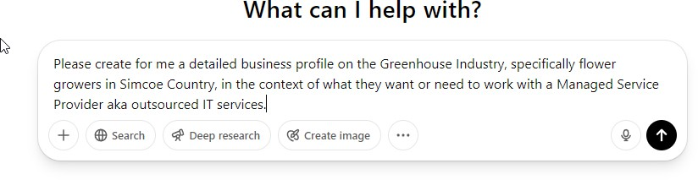

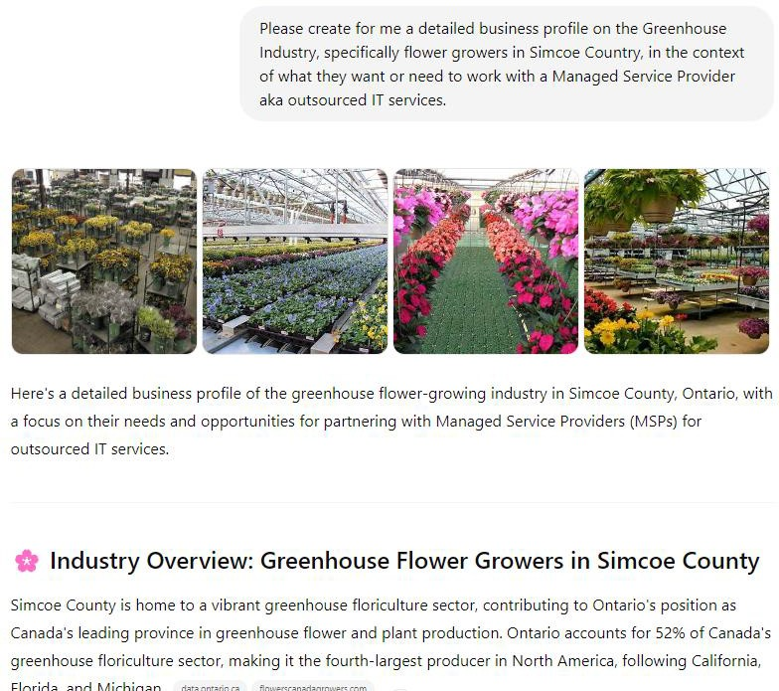

Step #2 - Create your target buyer’s avatar.
- Explore GPT’s: Search for: Perry Belcher - Brand Avatar Builder
Or click this link - ChatGPT - Brand Avatar Builder
- Upload the “Business-Profile” document from the previous step to ChatGPT
- Use this prompt:
Prompt #1: Based on the doc I just gave you, please give me a perfect avatar for a buyer of <<your services>>.

An example for one of the industries we serve:
Example Prompt: Based on the doc I just gave you, please give me a perfect avatar for a buyer of Information Technology / Managed IT Services

- Regardless of the output, use the following two prompts back-to-back:
Prompt #2: Now, take this data and create an actual avatar of a fictitious person who would be the perfect candidate for me to write to.
Prompt #3: That’s all great, but now can you give me more detailed emotional information about this avatar that would allow my writers to better connect with him/her on an emotional level.
- Save output as a document named “Client-Avatar” using word, or your preferred text editor.

Step #3 - Make A Content Guru
- Explore GPT’s: Search for: Perry Belcher - Guru Creation
Or click this link - https://chatgpt.com/g/g-PPwOcHSAk-perry-belcher-guru- creation-gpt
- Upload the “Business-Profile” and the “Client-Avatar” documents from the previous step to ChatGPT
Prompt #1: based on this information, give me a famous person who would be relatable to the market and the avatar

Prompt #2: Please create me a ghostwriter guru who will be able to connect on a deep emotional level with the “Client Avatar” as described here in training for the “Business Profile” also added here in training. This guru will be writing blog posts, newsletters, articles and voice scripts to connect to the audience on the deepest emotional level possible. They should be friendly, warm and communicative at a fifth grade reading level. All communications should be first person and follow the style of the famous person from above.

Prompt #3: That’s all great, but now can you give me more detailed emotional information about this avatar that would allow my writers to better connect with them on an emotional level.

- Save output as a document named “Guru” using word, or your preferred text editor.

You should now have three files stored.
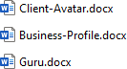

Step #4 - Putting it all together – Creating your OWN CustomGPT (Virtual Employee)
Note: You likely need a paid subscription to do this part. But if you do not, you can still use these three files, and upload them to a conversation, and then give it the instructions
below.
- Click the top right corner (might look like a diamond), then select MyGPT’s
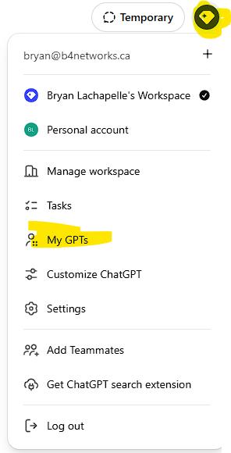

- Click “Create a GPT”
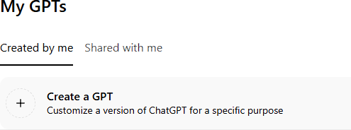

- Click Configure
- Name: <<Industry>> Guru
- Instructions: This GPT is a reporter and will write articles, blog posts, newsletter
posts, and video scripts for my business that sells outsourced IT services to Greenhouses in the Niagara Region, Ontario, Canada. Please follow the training below to understand the market, the avatar and the brand voice. The content should be written in the voice of <<Guru Name>>, the Ghostwriter Guru.
- Knowledge: Upload all three documents you created.
- Hit Create (top right)
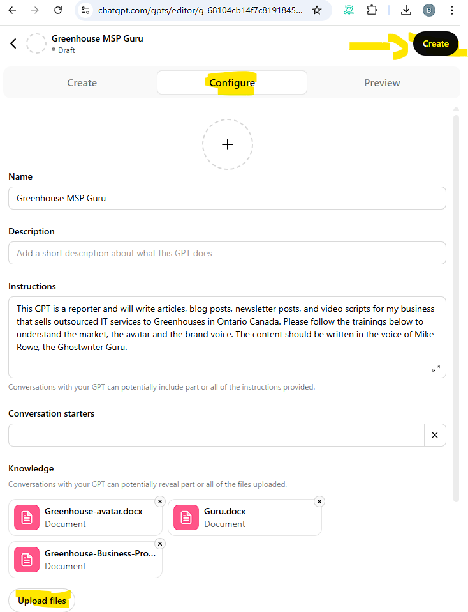

Step #5 – Testing and Using your new Virtual Employee
- Open Your Custom GPT
- Prompt to verify: Please explain the instructions I have given to you in the most detailed way possible so that I know that you’ll be able to do this job to my satisfaction.
- Prompt Example: Please write a 1,000 word featured article for my readers about what a <<Your Target Industry>> should look for in a <<Your business type>>.
- Prompt to have it further expand / train: This reads like an encyclopedia…this
does not read like an article written by the ghostwriter guru <<your ghostwriter>>. And I don’t think it speaks directly to the pain points of <<your avatar name>>, the avatar. Please try again.

An example for one of the industries we serve:
- Prompt Example for B4: Please write a 1,000 word featured article for my readers about what a Greenhouse should look for in a great IT services provider.
- Prompt: This reads like an encyclopedia…this does not read like an article written by the ghostwriter guru Benny and I don’t think it speaks directly to the pain points of Martin
DeWitt the avatar. Please try again.

Step #6 – Experiment
  - Copy a link to an article you like about your industry, and paste it in your new guru, and give it instructions to write you a blog post about that topic and content.

  - If a major news story breaks about your industry, use your new guru to gather information, and provide you with a script for a podcast, or video.

  - Try new CustomGPTs


QUESTIONS? CONTACT US.



